ZOOM BOOK LAUNCH:

METROPOLITAN INTIMACIES
AN ETHNOGRAPHY ON THE POETICS OF DAILY LIFE
By Francisco Cruces (Lexington Books, 2022)

NOVEMBER 17th, 17:30 (CET time, UTC+1)
With:

Orvar Löfgren (Lund University)

Martha Radice (Dalhousie University)

María Moreno Carranco (Universidad Autónoma Metropolitana de México)

Francisco Cruces (UNED)
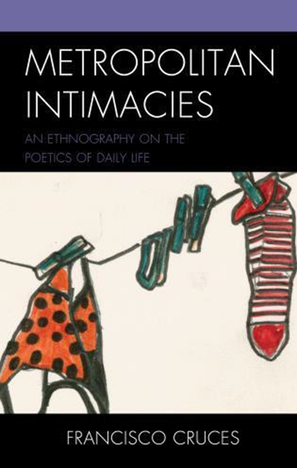
Join the zoom meeting:
https://uned-es.zoom.us/j/96004071044?pwd=a3FLaDB1N0t0M1dwOEdtdXlUeDBSUT09
Zoom ID: 960 0407 1044
Access code: 597775

Follow the streaming:
https://canal.uned.es/live/event/63352fe36f3c004f435b01c2

In Metropolitan Intimacies: An Ethnography on the Poetics of Daily Life, Francisco Cruces examines intimacy and meaning-making in metropolitan residents’ daily lives. An ethnography based on rich micro-stories, Cruces situates life poetics amongst other metropolitan processes in three major cities—Madrid, Montevideo, and Mexico City—to reveal the complex meanings around modern urbanity.

“This is a ground-breaking book for understanding the mysteries of everyday
life and as well as the role of intimacy in the new regime of urbanity.”

— Orvar Löfgren, Lund University

“Cruces shows us the modest miracle of how we make the world inhabitable.
We are in his debt.” — Ben Highmore, University of Sussex

“The thesis is original, the argument rigorous, the writing elegant—we are delighted to discover that poetry is not reserved for poets….Francisco Cruces succeeds brilliantly in combining the critical function of the social sciences with a vision that helps us live better.” — Jean-Claude Kaufmann, honorary research director, The French National Centre for Scientific Research (CNRS)

“Francisco Cruces captures the authentic yearning beneath consumer society's commodification of coziness….these micro-spaces of secure subjectivity are now under siege from the competitive self-making urged by neoliberalism and enabled by social media.” — Dorothy Noyes, The Ohio State University; President of American Folklore Society

ABOUT THIS BOOK

https://rowman.com/ISBN/9781793633217/Metropolitan-Intimacies-An-Ethnography-on-the-Poetics-of-Daily-Life

Discount code for orders: LXFANDF30 (30% discount, valid until dec. 2023).

ABOUT THE AUTHOR
Francisco Cruces is professor of anthropology at Universidad Nacional de Educación a Distancia (UNED).

